**PROJECT REPORT**

**INTRODUCTION:**

**1.1 Over view :**

* Tableau is a powerful data visualization and business intelligence tool developed by Tableau software, Which is now a part of Salesforce. It enables users to create interactive and shareable dashboards that allow for data analysis and storytelling.
  1. **PURPOSE**
* Apple’s entry into the Indian smartphone market has had a profound impact on the country’s technology landscape. The introduction of Apple phones in India has not only revolutionized the way Indians communicate but has also brought significant changes in various aspects of their lives.

**PROBLEM DEFINITION & DESIGN THINKING :**

**2.1 EMPATHY MAP**

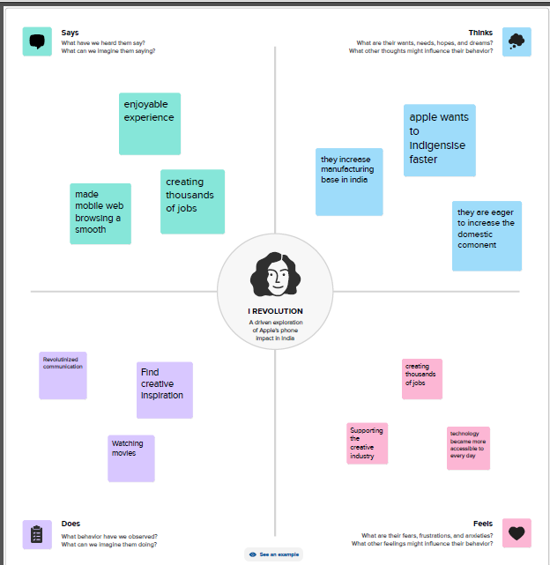

**2.2 IDEATION AN BRAINSTORMIG MAP**

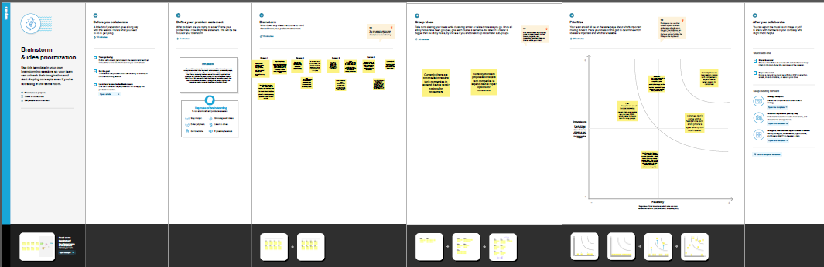

**3.RESULTS**

**Dashboard 1**

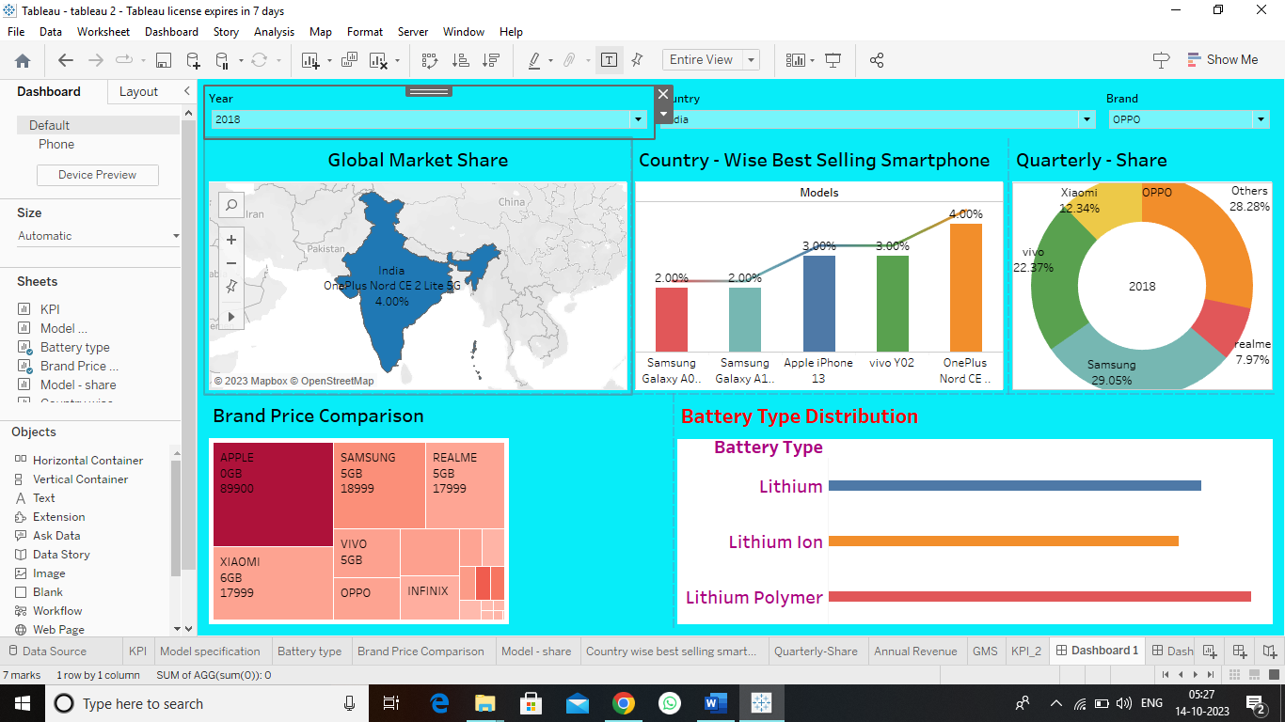

**Dashboard 2**

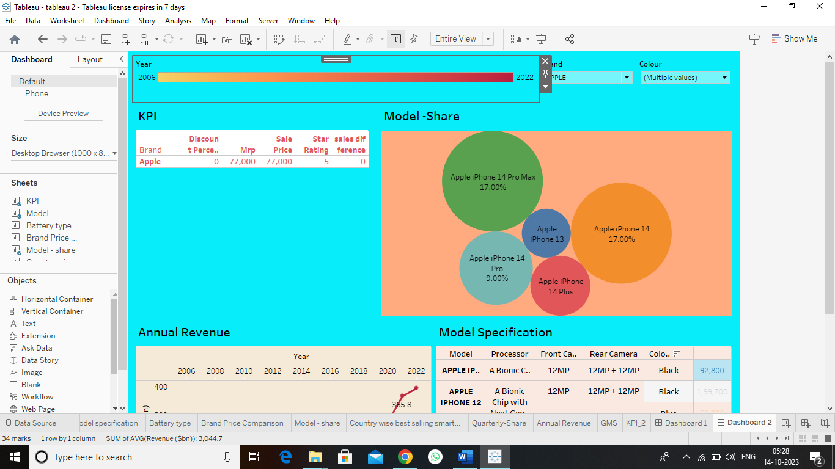

**Story**

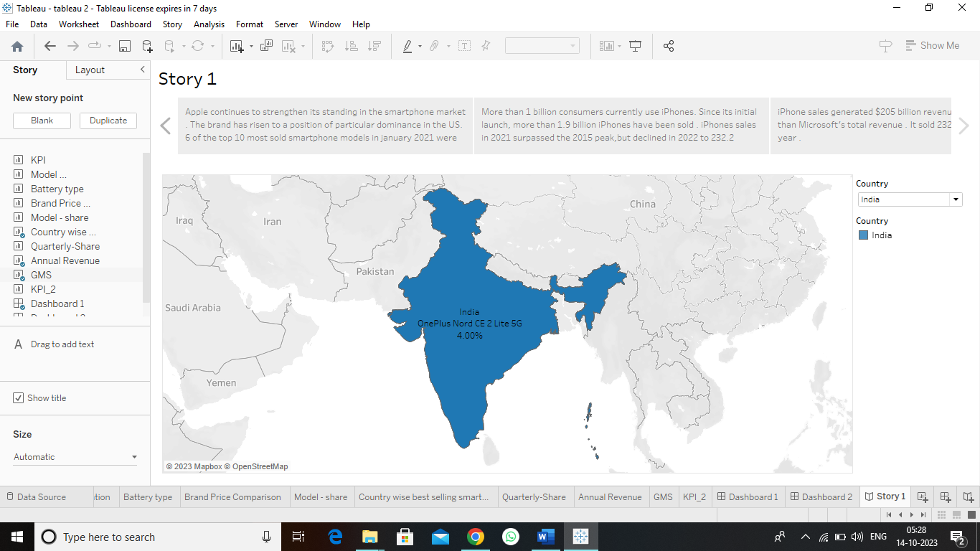

**ADVANTAGES :**

1. **Brand Reputation**: Apple is known for its premium quality and design. Owning an iPhone is often associated with status and prestige in India, which has a growing middle class with a strong desire for luxury products.
2. **Ecosystem Integration**: Apple devices, including iPhones, seamlessly integrate with other Apple products and services like MacBooks, iPads, iCloud, and the App Store. This can be especially attractive for individuals who use multiple Apple products.
3. **Software Updates**: Apple provides regular software updates and support for older devices. In a market where Android devices often receive limited or no updates, iPhones tend to have a longer usable life, reducing the need for frequent device upgrades.
4. **App Store**: The Apple App Store offers a vast selection of high-quality apps. Developers tend to prioritize iOS apps due to the relatively higher purchasing power of iPhone users, resulting in a better app ecosystem.
5. **Security**: Apple is known for its strong security features, including regular security patches, biometric authentication, and privacy measures. In a country where online security and data privacy are concerns, iPhones are often considered more secure.
6. **Resale Value**: iPhones tend to retain their value better than many Android phones. This means that when users decide to upgrade, they can often sell their old iPhone at a higher price compared to Android devices.
7. **Local Manufacturing**: Apple started manufacturing some iPhone models in India, which has led to reduced import costs and potentially lower prices for consumers. This supports the "Make in India" initiative.
8. **Financing Options**: Apple and various financial institutions have introduced affordable financing options and trade-in programs, making iPhones more accessible to a wider range of consumers.
9. **Camera Quality**: iPhones are known for their excellent camera quality, which is appealing to the growing number of Indian users interested in photography and social media.
10. **Education and Business Use**: iPhones are often chosen by students and professionals for their reliability, software support, and productivity features, which are essential for educational and business purposes.

**DISADVABTAGES :**

1. High Price Point: Apple iPhones are generally more expensive compared to many other smartphone brands in India. This high price point can make them less accessible to a significant portion of the population, limiting their market share.
2. Limited Local Manufacturing: Apple has been gradually increasing its local manufacturing in India to reduce import costs and comply with local regulations. However, the majority of iPhone components are still imported, which can lead to higher prices and potential supply chain disruptions.
3. Limited Market Share: In India, Apple faces stiff competition from more affordable Android smartphones, which dominate the market. Apple's market share in India has traditionally been lower compared to other regions, partially due to the high cost of its devices.
4. **Manufacturing and Assembly**: Apple has been gradually increasing its local manufacturing and assembly operations in India. This helps reduce costs and import duties, making iPhones more affordable for the Indian market. Expanding manufacturing capabilities and supply chain partnerships can further benefit the company.
5. **Retail Expansion**: Apple has been opening more retail stores and expanding its authorized reseller network in India. With the growing middle class and increasing disposable income, there's a significant market for premium Apple products. Expanding the retail footprint can help tap into this market.
6. **Localization**: To cater to the diverse Indian market, Apple has been working on software and feature localization. This includes support for multiple Indian languages, region-specific features, and content. Further investments in localization can improve the user experience.
7. **Affordable Models**: India is a price-sensitive market, and Apple has recognized the need for more affordable iPhone models. Launching budget-friendly options can help capture a larger share of the market, especially in the mid-range segment.
8. **E-commerce Partnerships**: Apple has been partnering with major e-commerce platforms in India for exclusive product launches and promotions. Strengthening these partnerships can increase product accessibility and visibility.
9. **Services**: Apple has been promoting its services like Apple Music, Apple TV+, and the App Store in India. The growth of the digital ecosystem and the popularity of content streaming make this a lucrative area for expansion.
10. **Educational Initiatives**: India has a burgeoning education and technology sector. Collaborations with educational institutions and initiatives that support digital learning can open up new opportunities for Apple products, especially in the education sector.
11. **5G Adoption**: As 5G technology continues to roll out in India, Apple can capitalize on this by introducing 5G-enabled devices and services.
12. **Environmental Initiatives**: Sustainability and environmental concerns are becoming increasingly important in India. Apple's efforts to reduce its carbon footprint and promote renewable energy can resonate with the environmentally conscious Indian consumer.
13. **Wearables and Accessories**: The market for wearables, including Apple Watch and AirPods, has been growing steadily. Apple can further penetrate this market by introducing new products and features tailored to the Indian consumer.
14. **Government Relations**: Building positive relationships with the Indian government and navigating local regulations and policies are crucial for Apple's continued success in the country.

**CONCLUTION :**

Apple had started manufacturing some of its iPhone models in India through contract manufacturers. This move not only helped in reducing the cost of iPhones but also contributed to job creation and the growth of the local manufacturing industry.

**THANKYOU**